Tripping on aesthetascs - Eli Nettlebeck, Oliver Parsons, Sidney Rich, Maya Rios
Spring 2026
Fish 460

Research question -
- How does thermal stress impact chemoreception in shore crabs? Do elevated temperatures affect reception and response time for crabs experiencing food and predator-related chemical cues?

Hypotheses -
- More antennule flicking correlates with a higher stress response in Hemigrapsus oregonensis.

- H. oregonensis held at elevated temperatures will show elevated respirometry results, indicating a heightened metabolic rate.
- H. oregonensis held in control conditions will find food faster than elevated temperature treatments.
- Control H. oregonensis crabs will respond to predator chemical cues with more antennule flicking (higher rates of water sampling) relative to crabs held at elevated temperatures.

Figures -

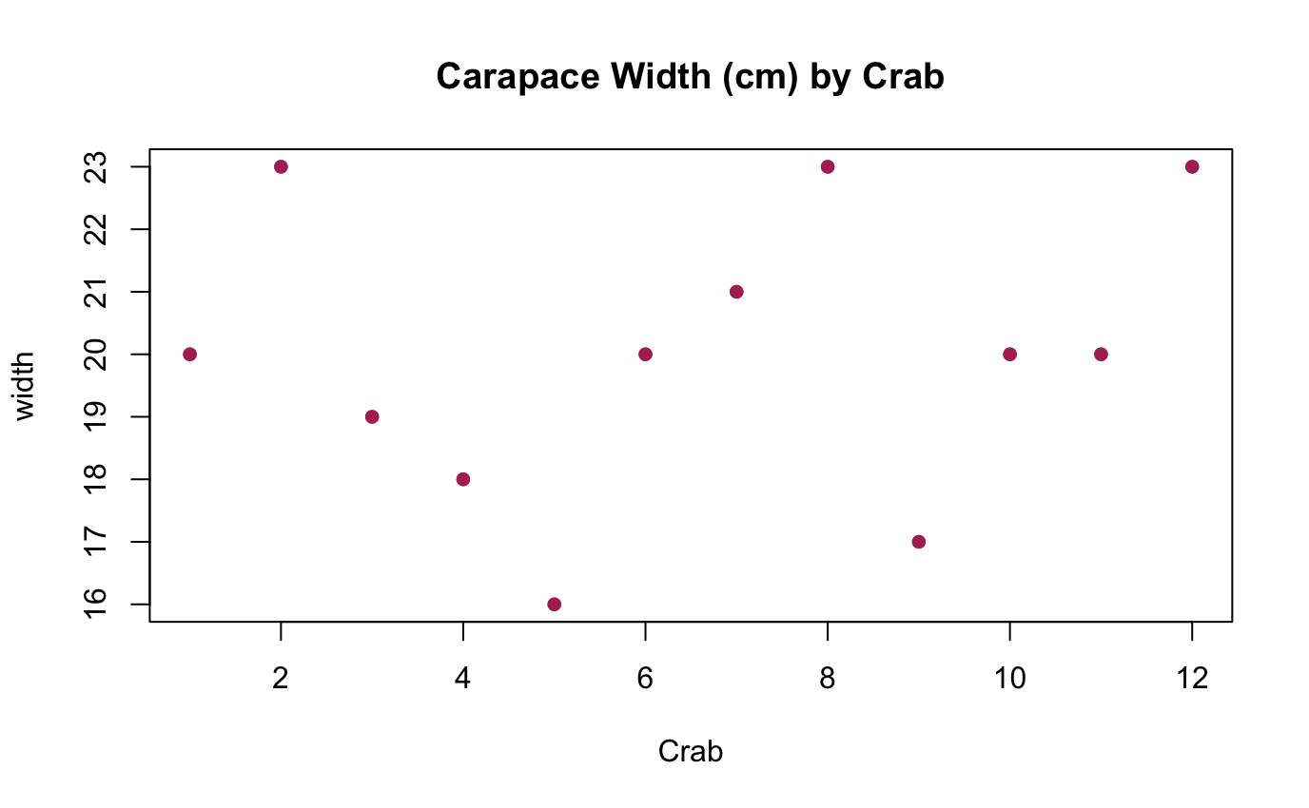
This figure shows the size distribution of our control group, crabs #1-6, and our testing group, crabs #7-12, to demonstrate that the groups are relatively well mixed.
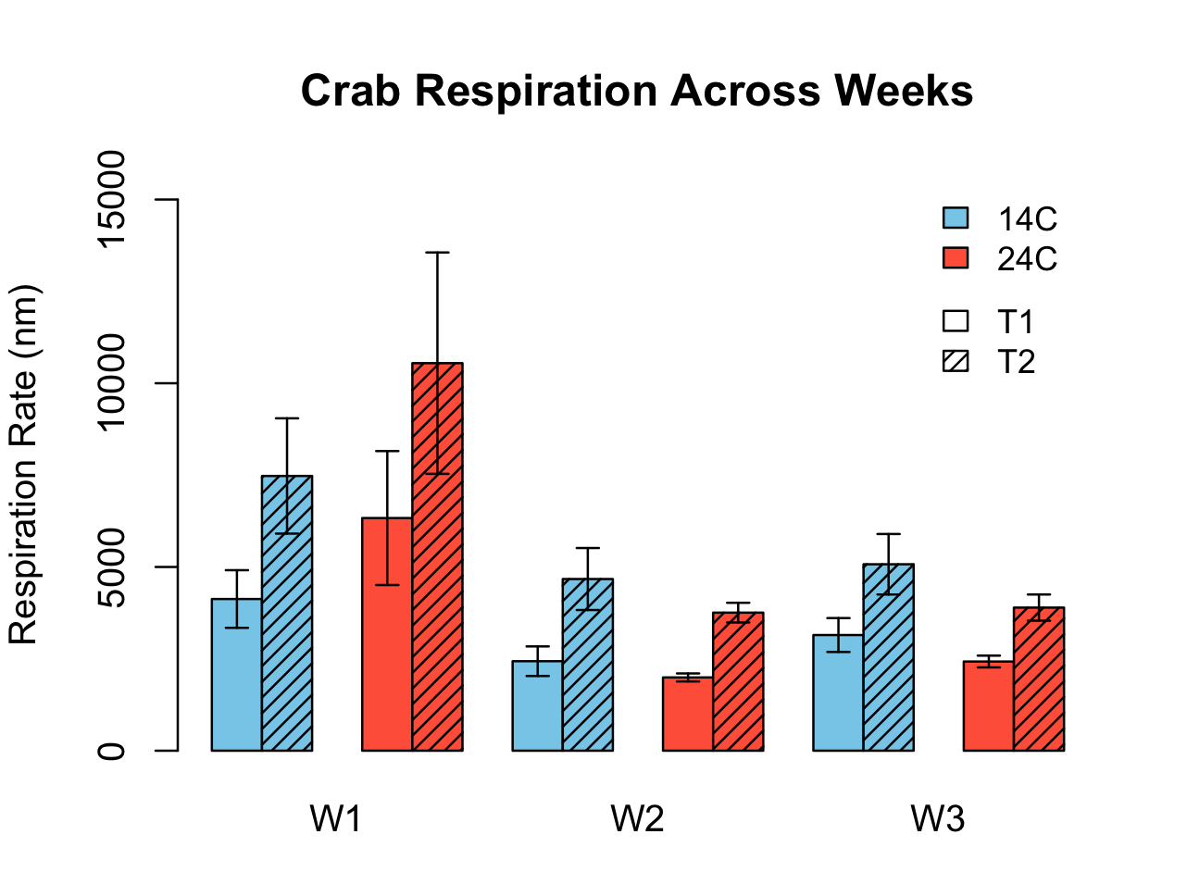This graph showcases the respiration rate of Hemigrapsus oregonensis across our testing periods. T1 is the first reading taken from our crabs, and T2 is the second reading in the same week. Crab 12 was only part of week 1 in the 24C group, since it died between week 1 and week 2. It also had an extremely high respiration rate (reflected in the error bar), which may corroborate with it dying soon after, but that may have skewed the data for the 24C group in week 1.

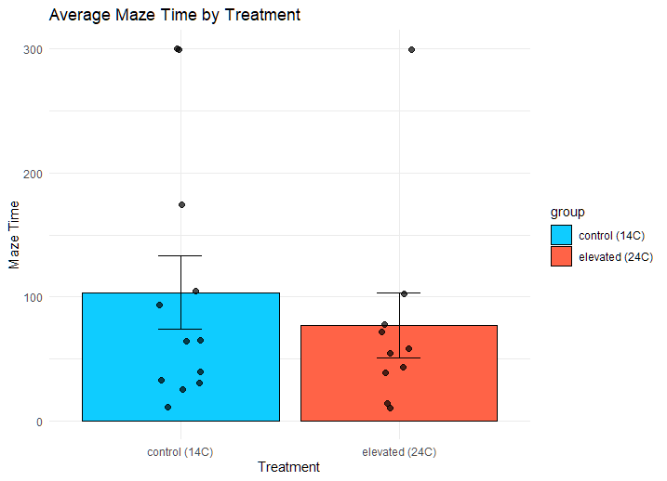
This graph shows the average time (in seconds) it took for crabs to find food in the maze with individual data points overlaid on the bars. Individuals that spent 5 minutes in the maze were considered to have failed to find the food. On average, the control group took longer to find food, but it is not a significant difference.

Key takeaways -

The crabs held in elevated conditions initially respired more compared to the ones held in control temperatures. However, respiration rate subsequently decreased for crabs in the testing group; after three weeks in the elevated temperature tank, the experimental crabs showed signs of acclimation, as demonstrated by respiration rates comparable to the control group. Crabs held in elevated temperatures responded more quickly to a food cue, with a lower average time taken to locate food.

